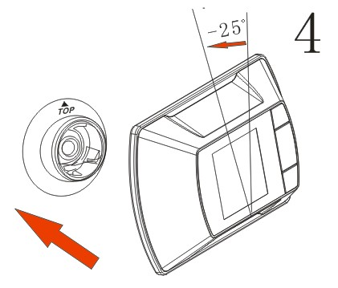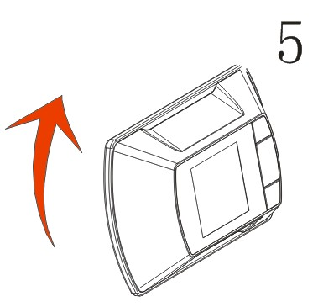
4 .Hold the Peephole Viewer at a-25 degree counter-clockwise position and insert it onto Base Flange.
5 .Rotate the Peephole Viewer clockwise until horizontal and you feel it lock in place.
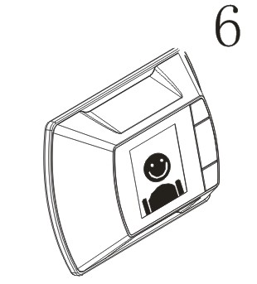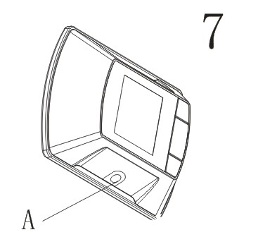

6 .Press the Power button,and check the image on the LCD.Now you can press the power button again a few times to practice cycling through the different viewing modes.
7 .Use the screwdriver to tighten the locking Screw.You are new ready to turn the Peephole Viewer on.
3

Electronic Digital Peephole System
User's Manual

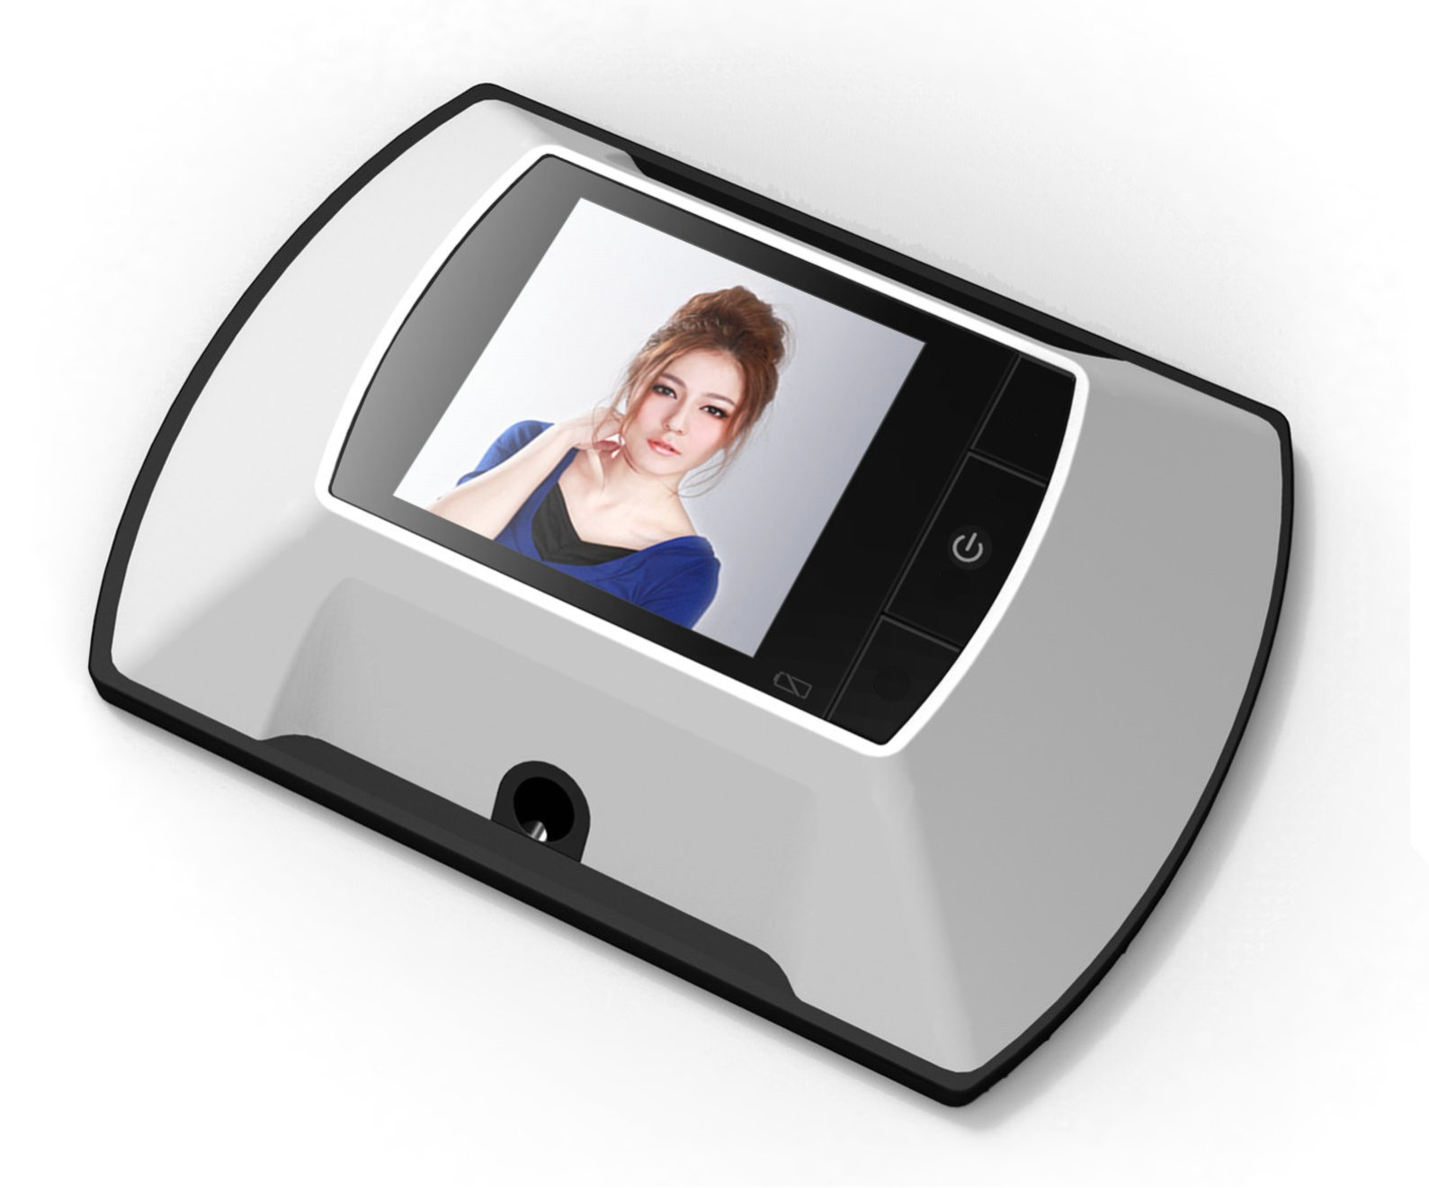

Before operating the unit, please read this manual carefully.
The information in this article may be change if the company improve products to enhance the reliability and the design of the main parts of the original and function , such as without notice。

FUNCTION DECLARATION
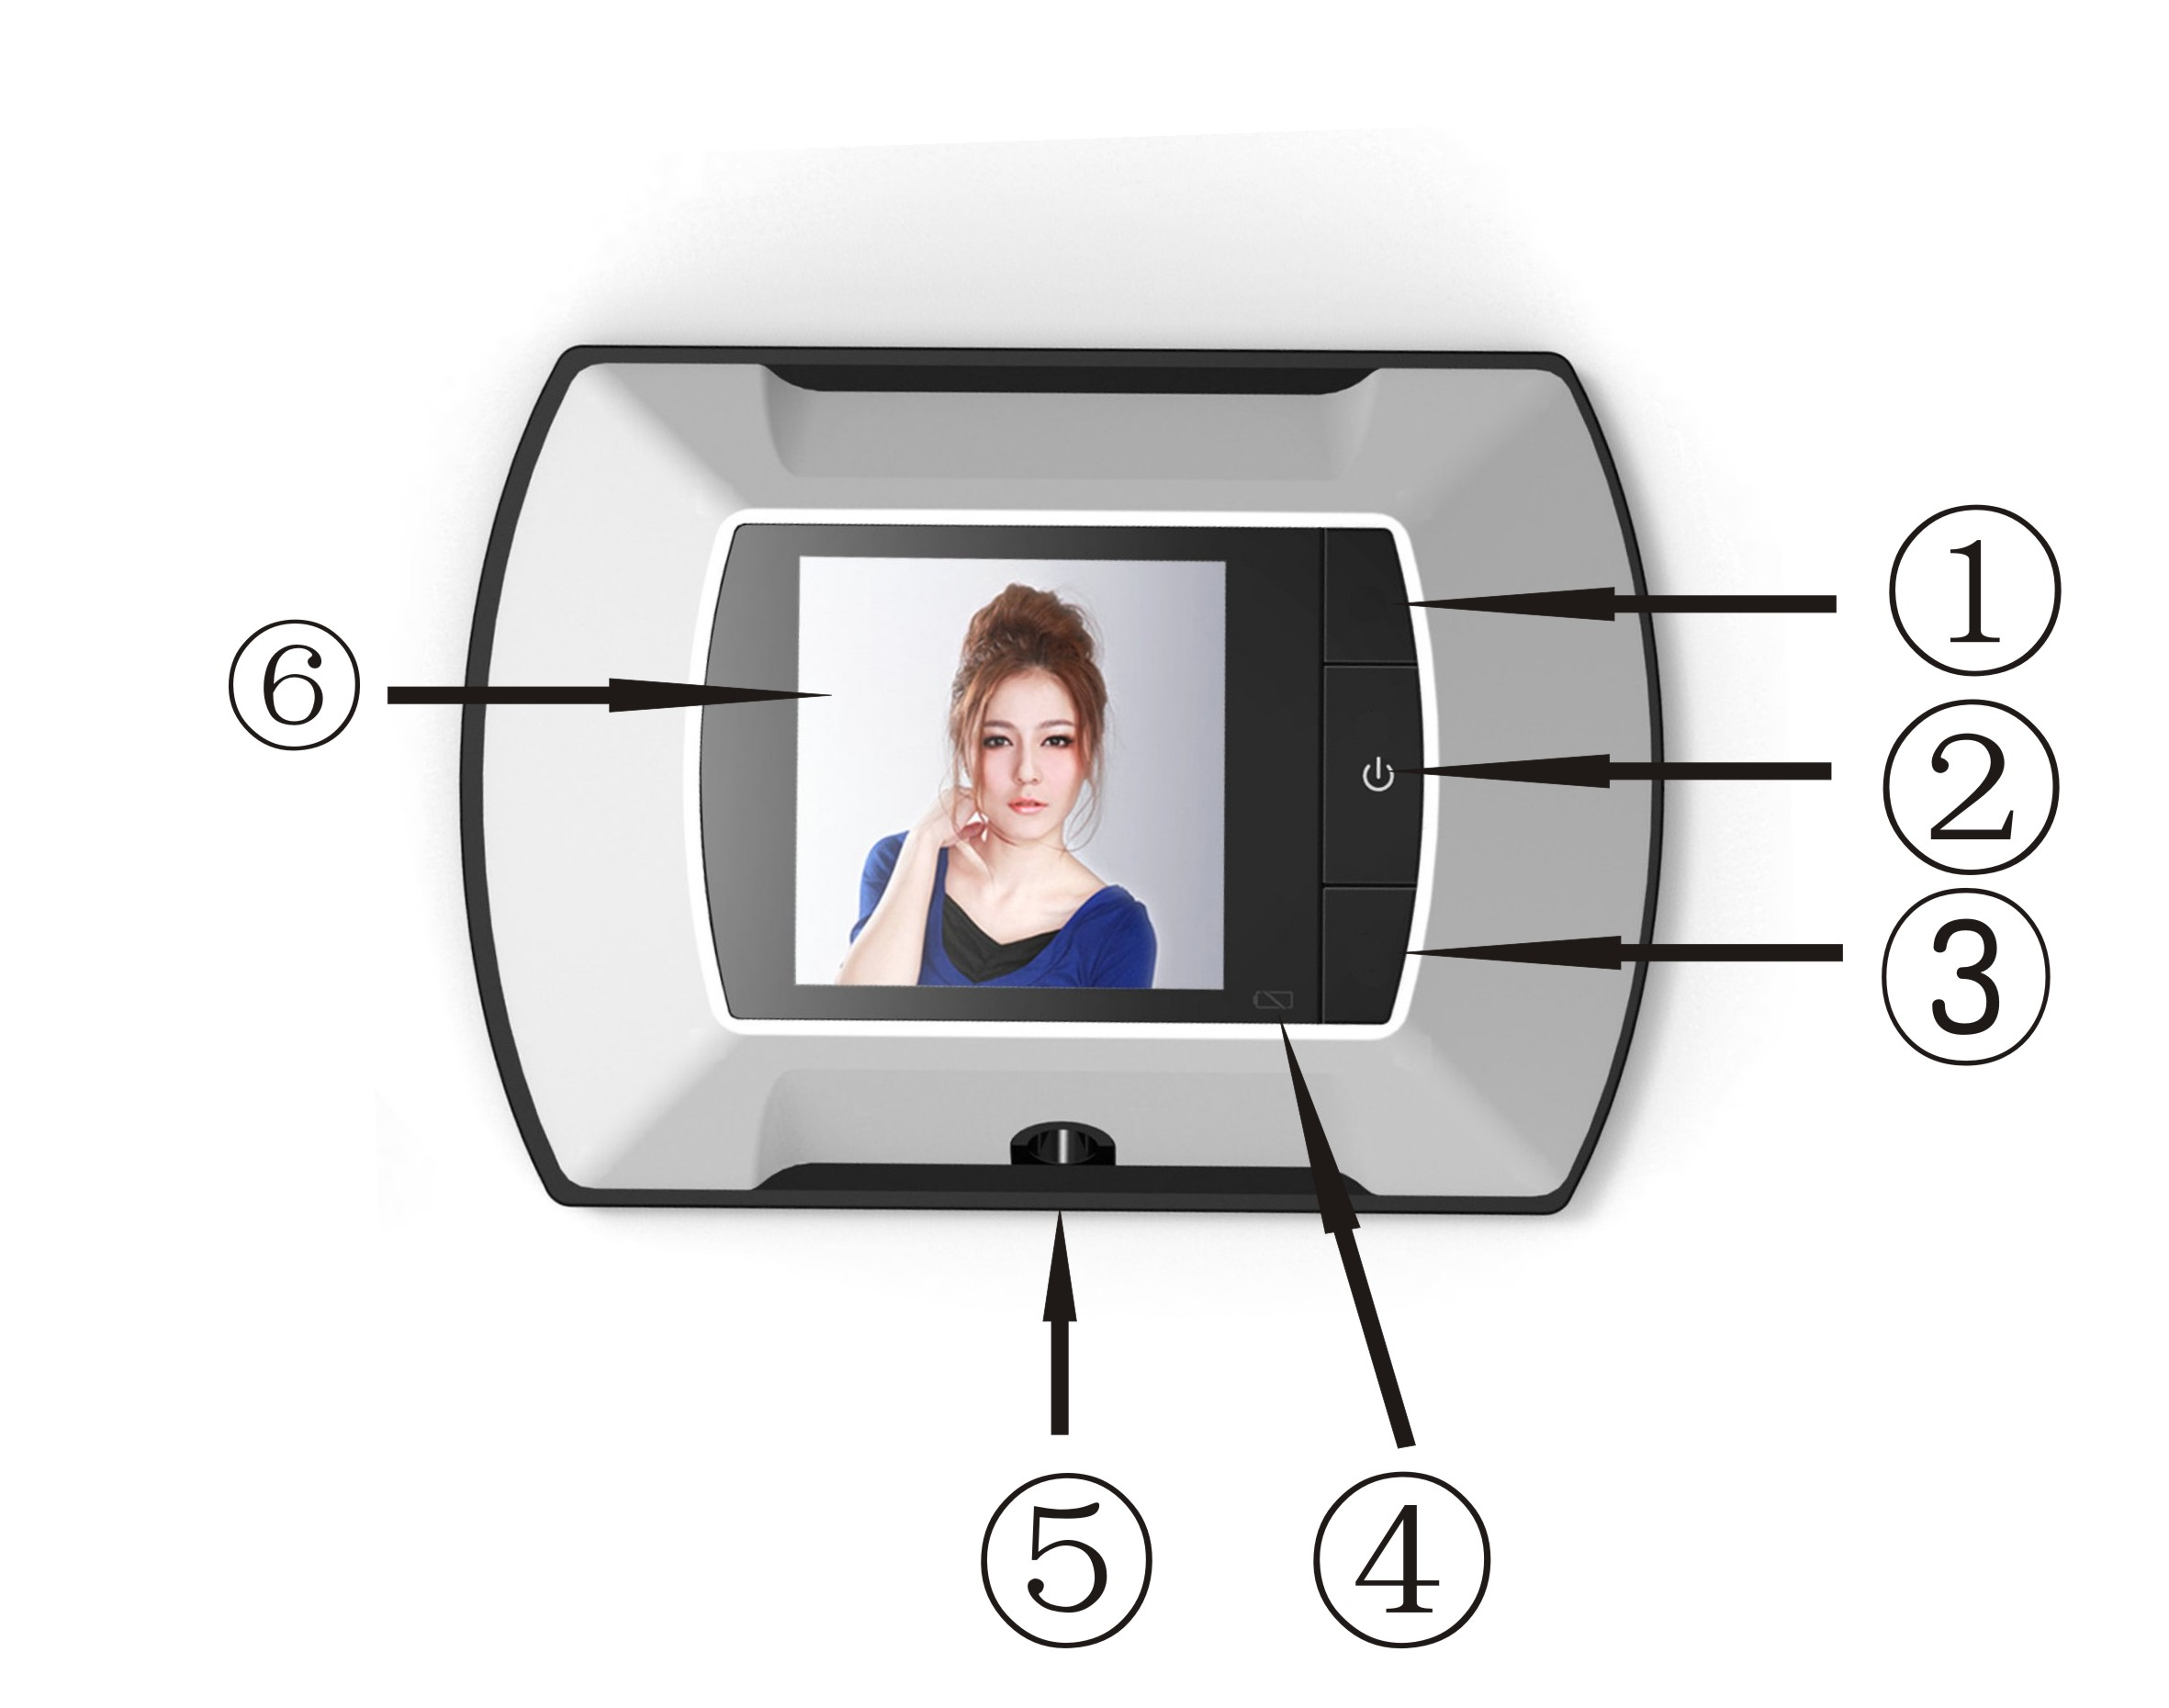
①-③ A decorative role, no function
② Power
④ Low electricity remind function. The battery power is less than work, the indicator will light, said the battery needs to be replaced.
⑤ Nut lock, fixed products
⑥ 2.4 inch LCD screen
COMPOSITE IMAGE
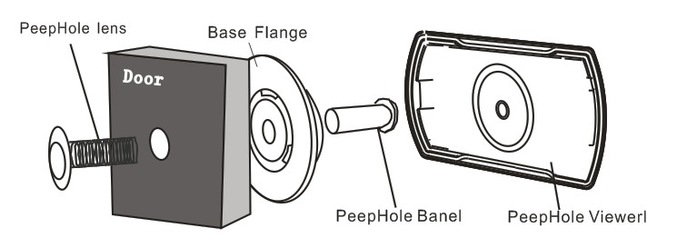
1
EXPLODED VIEW
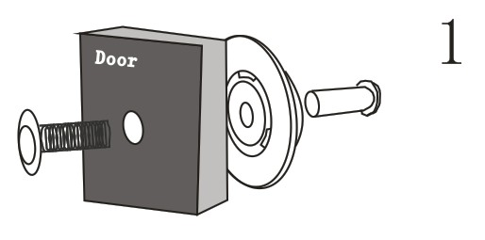
1.Insert Peephole lens in the outside of the door
Insert the Peephole barrel through Base Flange and insert both the hole on the inside of the door.Tighten the Peephole Barrel with your fingers.

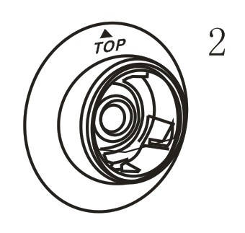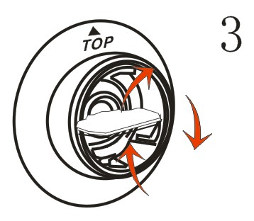
2.When the barre is snug,rotate the base flange until the TOP icon is at 12 o'clock(vertical).
3.Use the Tightening Tool included to tighten the Peephole barrel.
2

